Date Name Issue General Detailed Present Future Past Actual
Version

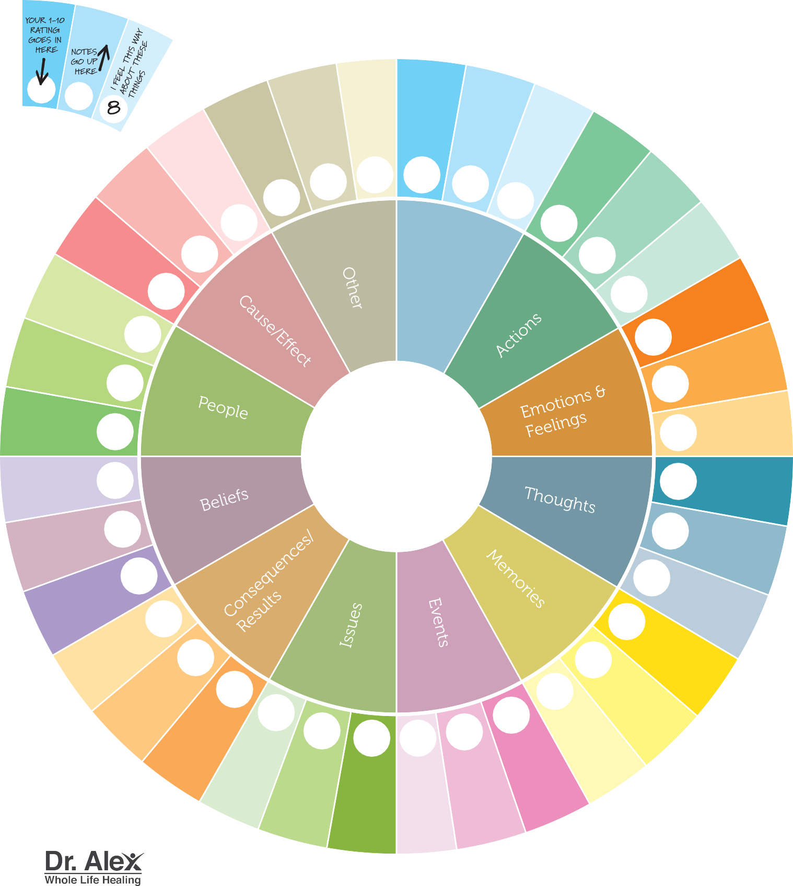

Example

My Story

